Report

Big Mountain resort is a high-end ski resort located in Montana. A new chair lift increases the costs by $1.54M this season. To increase revenue by $1.5M, the resort needs better ticket pricing by either cutting operational costs or increasing the ticket price. We develop a model to disclose the market pricing rule based on the data containing various features of ski resorts in the United States.

The random forest model outperforms the linear regression model and can be generalized to new data because of the cross-validation. As shown in Figure 1, the top four features suggested by the model are the number of fast four-person chairs, number of runs, total area covered by snow-making machines, and vertical change in elevation of a resort. The model corroborates that the current price of $81 does not reflect that the resort has adequate competing facilities. The current model predicts the ticket price outstanding $ 95.87 ± 10.39, and the lower limit still suggests that there is room for increasing the ticket price.

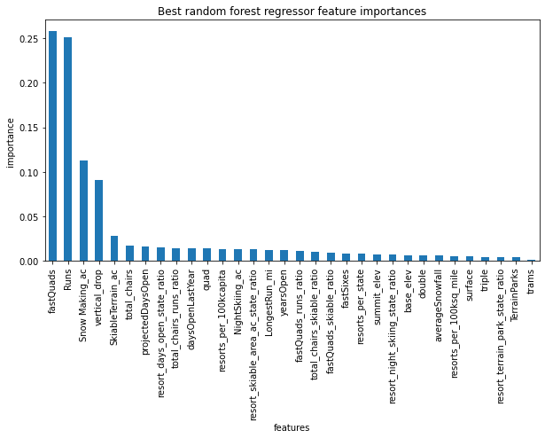

Figure 1 Ranking of importance of features in the random forest model

To cut costs, the resort can close some of the least used runs, which impacts on the modeled ticket price and revenue. As shown in Figure 2, the closing number of runs can decrease the ticket price and revenue. But people may not like a higher ticket with fewer runs than the previous season.

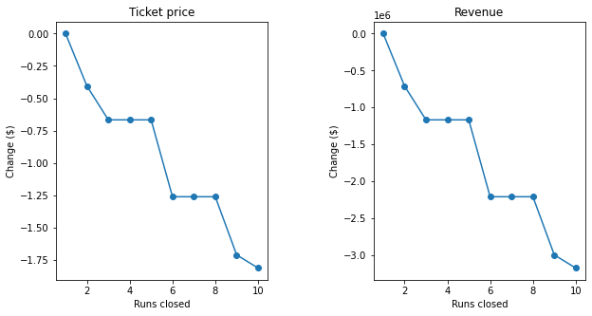

Figure 2 Closing runs impacts the single ticket price and revenue

Adding the ticket price is the best way to increase revenue. The model predicts that adding a run, increasing the vertical drop by 150 feet, and installing an additional chair lift can raise the ticket price by $8.6 and the expected revenue by $15M.

Operation costs are important to test whether and how it impacts the pricing model.